**Practical No:01**

**OOPs Concepts in Java-1**

1. **Write a program to create a class and implement a default, overloaded and copy constructor.**

**Code:**

import java.util.*;

class BookDetails

{

String title,author;

int ISBN,pub_year;

BookDetails() //Default constructor

{

title="My Rule";

author="Vedika Lalit";

ISBN=101;

pub_year=2005;

}

BookDetails(String t,String a,int bn,int year) //Parameterized constructor

{

title=t;

author=a;

ISBN=bn;

pub_year=year;

}

BookDetails(BookDetails b) //Copy constructor

{

title=b.title;

author=b.author;

ISBN=b.ISBN;

pub_year=b.pub_year;

}

void display()

{

System.out.println("Title: "+title);

System.out.println("Author: "+author);

System.out.println("ISBN:: "+ISBN);

System.out.println("Publication Year: "+pub_year);

System.out.println(" ");

}

public static void main(String[] args)

{

BookDetails b=new BookDetails();

b.display();

BookDetails b1=new BookDetails(“My Shadow”,”Vedika Lalit”,102,”2006”);

b1.display();

BookDetails b2new BookDetails(“Sign of Four”,”Vedika Lalit”,103,”2007”);

b2.display();

BookDetails b3=new BookDetails(b1);

b3.display();

}

}

**Output:**

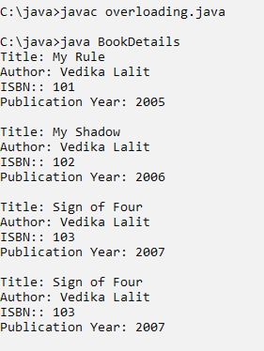

1. **Write a program to create a class and implement the concepts of Method Overloading.**

**Code:**

class Concat

{

void con(String s,String s1)

{

System.out.println("Your String: "+(s+s1));

}

void con(String s,String s1,String s2)

{

System.out.println("Your String: "+(s+s1+s2));

}

void con(String s,int n)

{

System.out.println("Your String: "+(s+n));

}

public static void main(String[] args)

{

Concat c=new Concat();

c.con("SRM","College");

c.con("SRM","College","Kudal");

c.con("SRM",12);

}

}

**Output:**

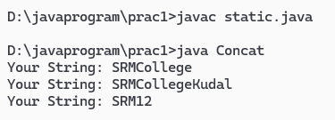

1. **Write a program to create a class and implement the concepts of Static methods.**

**Code:**

import java.util.*;

class StudentDetails

{

String name,classes;

int age;

static int total_student=0;

StudentDetails(String n,int a,String cls)

{

name=n;

age=a;

classes=cls;

total_student++;

}

void display()

{

System.out.println("Name: "+name);

System.out.println("Age: "+age);

System.out.println("Class: "+classes);

System.out.println(" ");

}

static void TotalStudent()

{

System.out.println("Total Student: "+total_student);

}

public static void main(String[] args)

{

StudentDetails s=new StudentDetails("Vedika Lalit",20,"SY.Bsc.IT");

s.display();

StudentDetails s1=new StudentDetails("Shardul Kudav",20,"SY.Bsc.IT");

s1.display();

StudentDetails s2=new StudentDetails("Divya Sutar",20,"SY.Bsc.IT");

s2.display();

StudentDetails.TotalStudent();

}

}

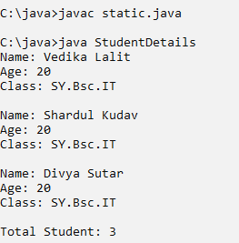**Output:**